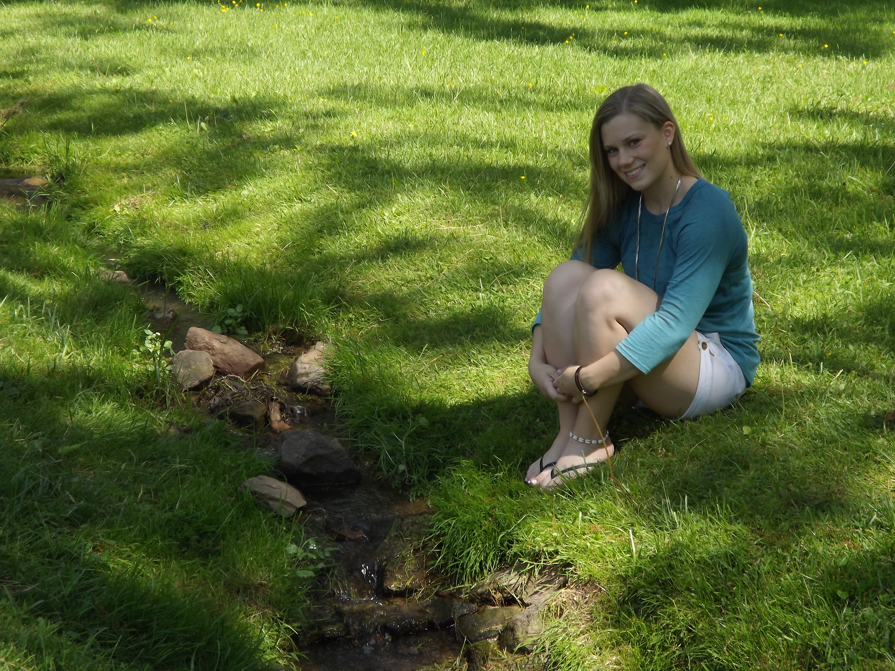
Rebecca Dobson
484-354-8069
Rdobson2014@gmail.com
www.rebeccaannedobson.com
Height: 5’0” | Weight: 130
Eyes: Hazel | Hair: Blonde

PRODUCTIONS
HIGH SCHOOL
The Drowsy Chaperone | Featured Dancer |  |  |  | Phoenixville Theatre
Alice in Wonderland | Featured Dancer |  |  |  | Phoenixville Theatre
COMMUNITY THEATRE
Fiddler on the Roof | Mother/ Featured Dancer |  |  |  | FaceTime Theatre
The Music Man | Stage Crew |  |  |  | FaceTime Theatre
RELATED EXPERIENCE
Dunkin Donuts Thanksgiving Day Parade | Dancer |  |  |  | Ocean City Theatre Company
DARS Instructional Video | Voiceover |  |  |  | Temple University
TRAINING
Voice | Katherine Nice, Randi Carp
Jazz (Intermediate) | Feet First Dance/ Spotlight Dance Center
Hip Hop (Beginner/Intermediate) | Spotlight Dance Center: Chris Lupis
Tap (Beginner) | Feet First Dance/ Diane Hodgkiss
Gymnastics | USAG Level 9 Silvia’s Gymnastics: Maia Mitova
SPECIAL SKILLS: advanced tumbling and gymnastics, licensed driver, great with kids and animals, climbing, impressions- Stitch

